CETI Sonar Binocular Microscope

Total Magnification: 7 to 45 times. Specimens can be lit from above/below

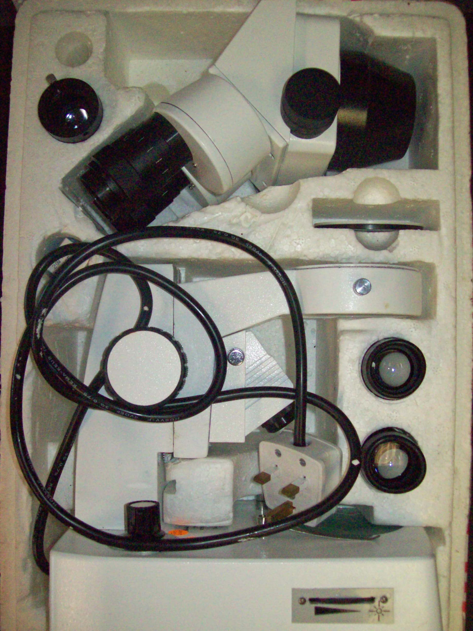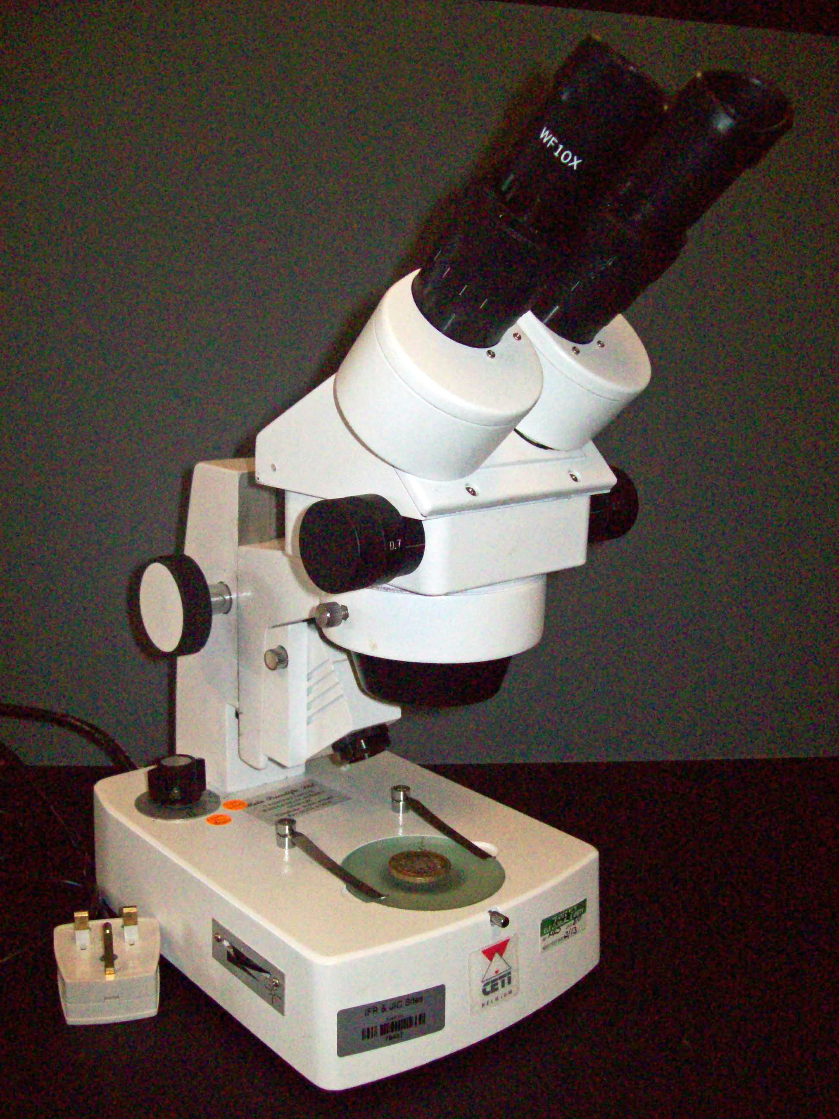

In Box: remove carefully from polystyrene carrier. Screw eyepiece tube into body of microscope and slot in 2 x eyepieces
Out of Box: your microscope is ready to use to view specimens with top-lighting or by lighting specimens from below.
Types of Illumination:

The opacity of the specimen is generally the most important characteristic in determining the type of illumination to use. However, it should be noted that many objects reveal their characteristics best through a combination of both transmitted and reflected light

Diascopic Illumination:
Translucent and transparent specimens produce the clearest and most vivid images when lit by transmitted illumination, be it brightfield, polarized, oblique or darkfield. Diascopic light transmitted at an oblique angle can often deliver greater contrast and produce images of enhanced clarity.

Episcopic Illumination:
Predominantly used for lighting opaque specimens from above. A variety of orientations of light are used to best expose the features and characteristics of interest

